STOCK MAINTAINANCE SYSTEM..

**USE CASE DIAGRAM**

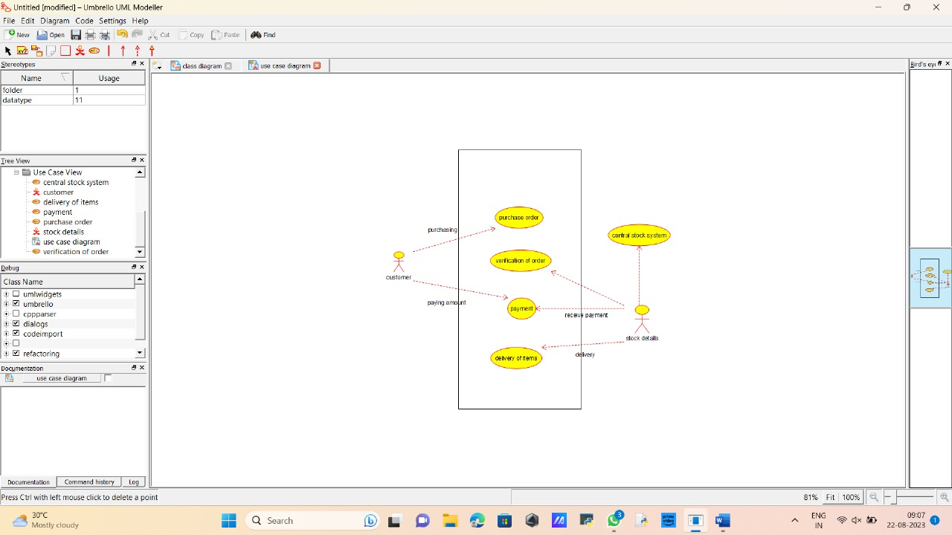

**CLASS DIAGRAM**

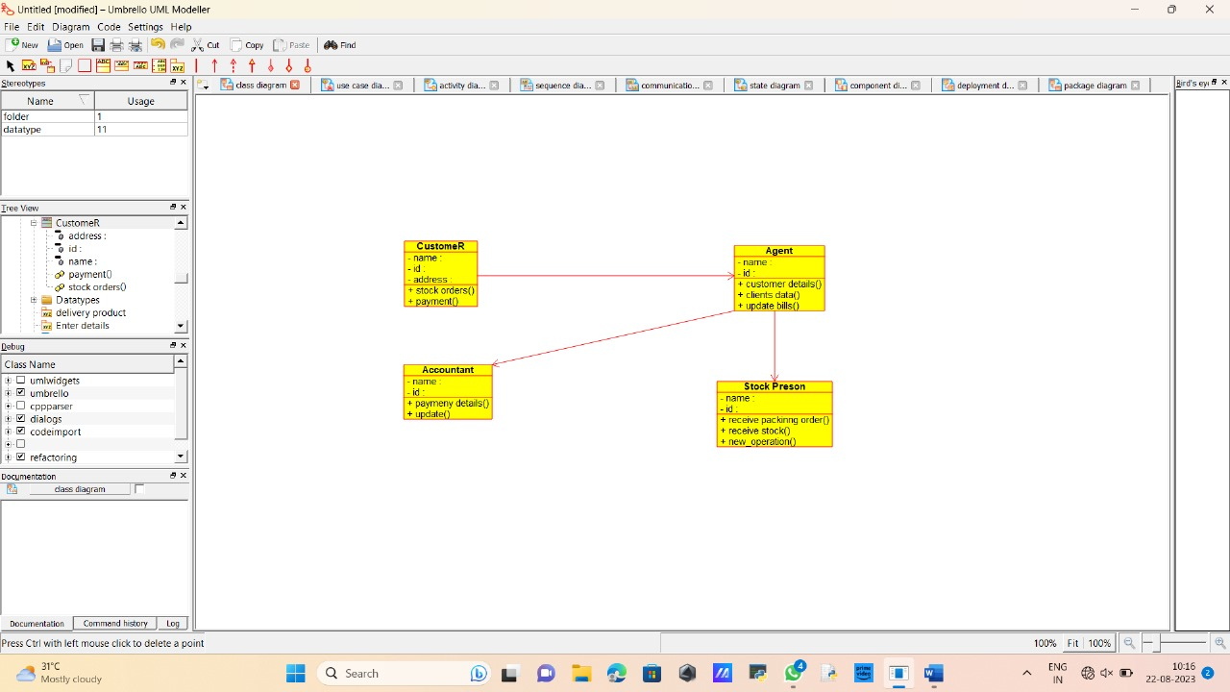

**ACTIVITY DIAGRAM**

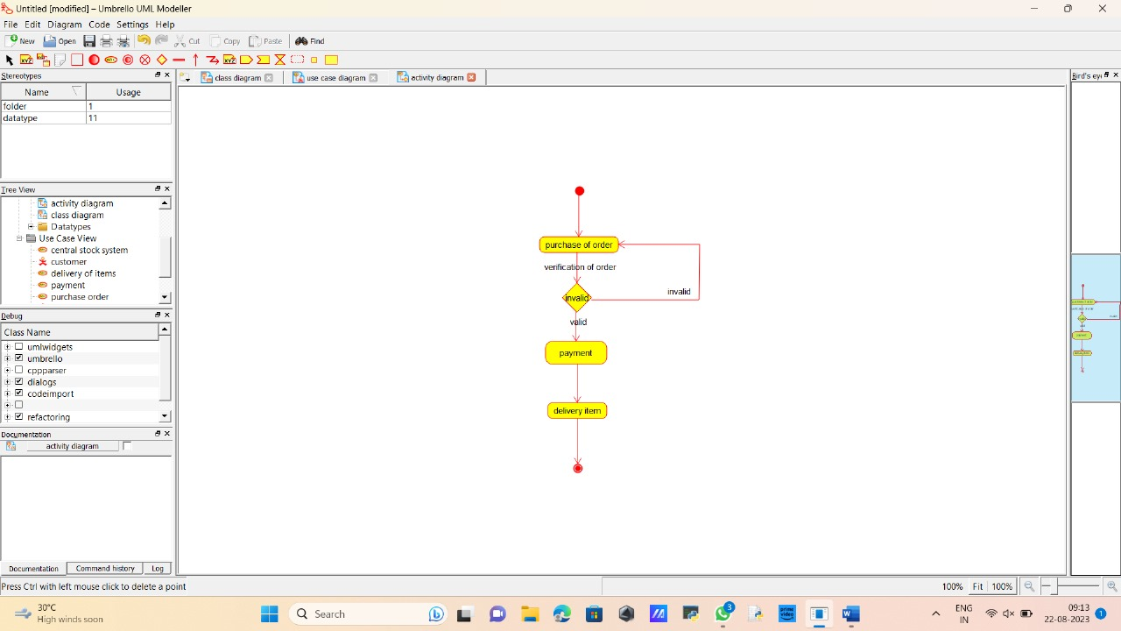

**STATE CHART DIAGRAM**

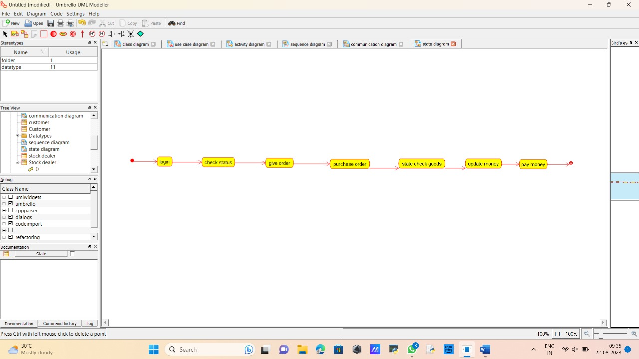

**SEQUENCE DIAGRAM**

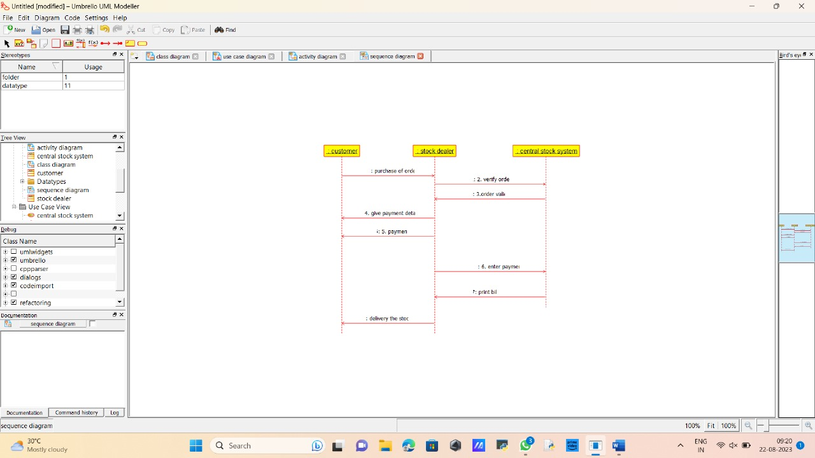

**COLLABORATION DIAGRAM**

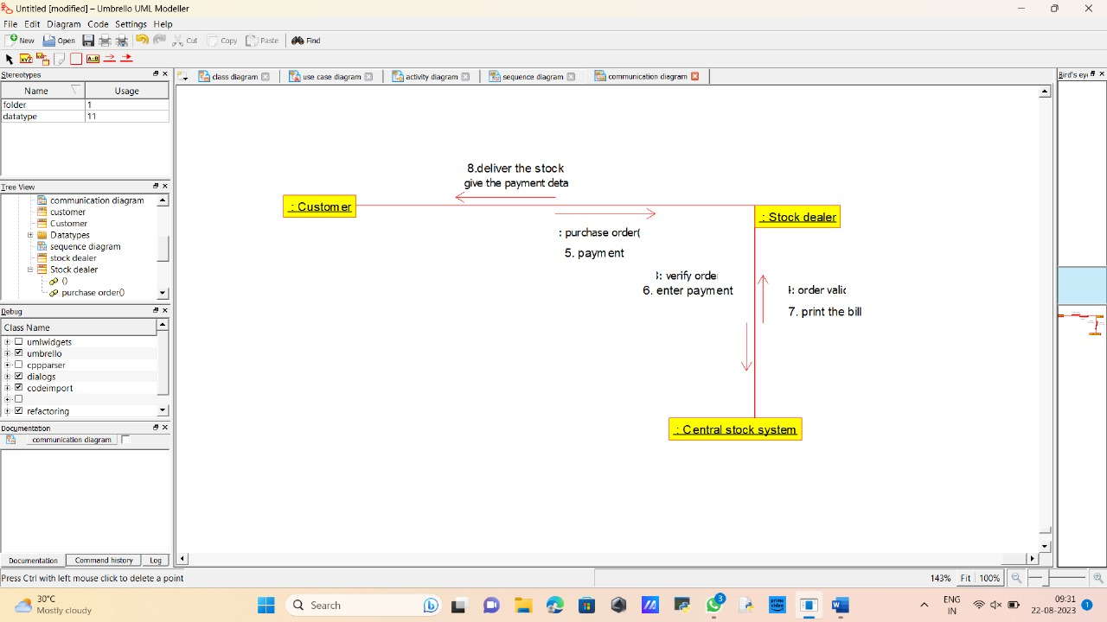

**COMPONENT DIAGRAM**

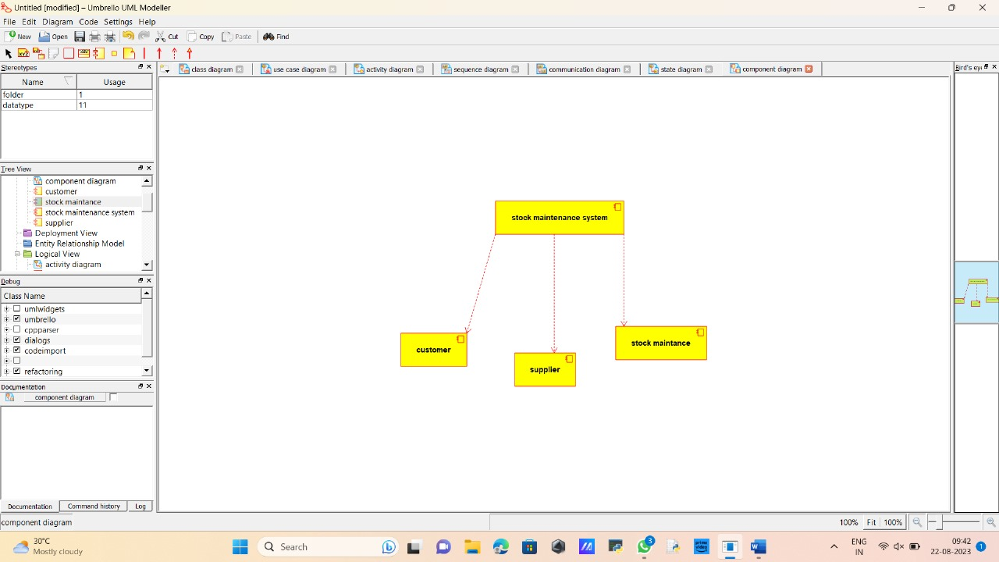

**PACKAGE DIAGRAM**

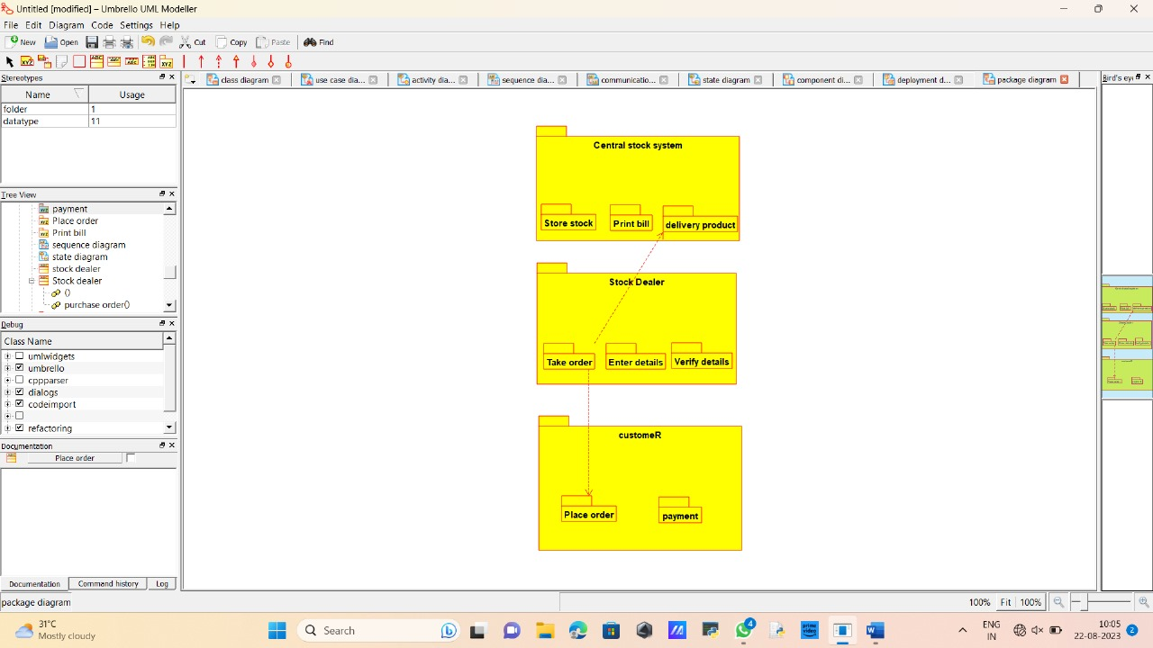

**DEPLOYMENT DIAGRAM**

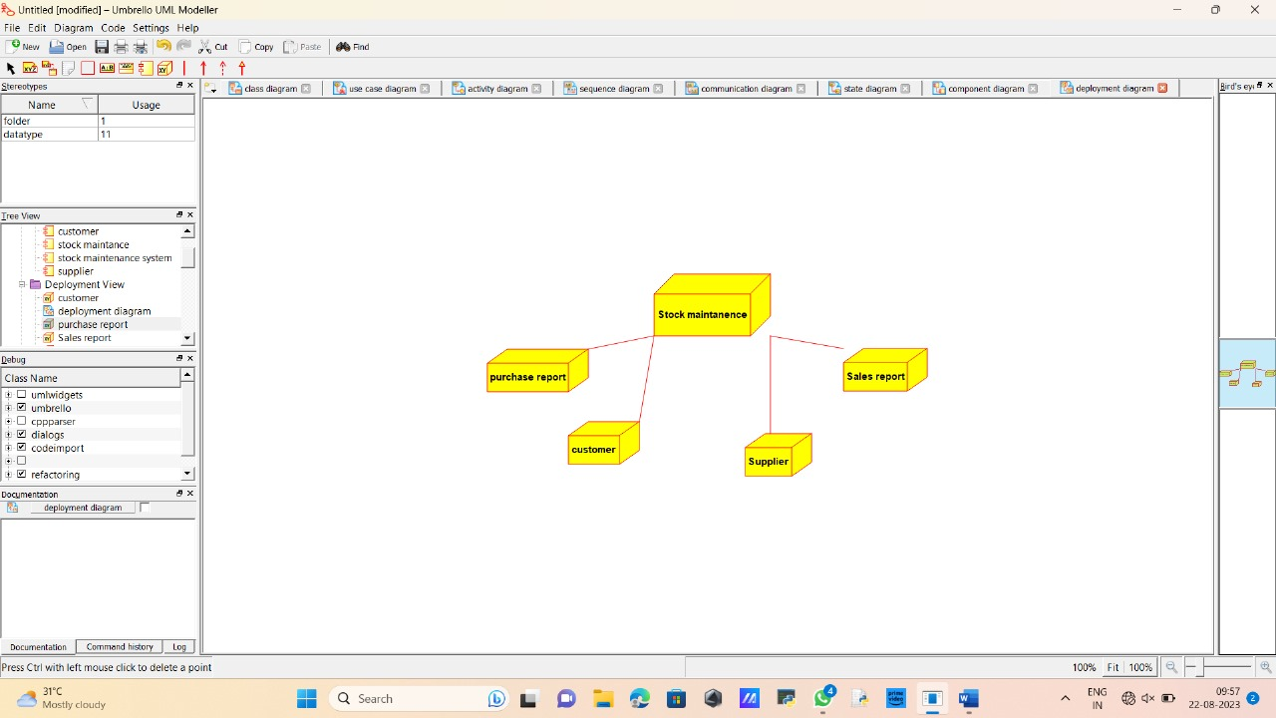

**PROGRAM**

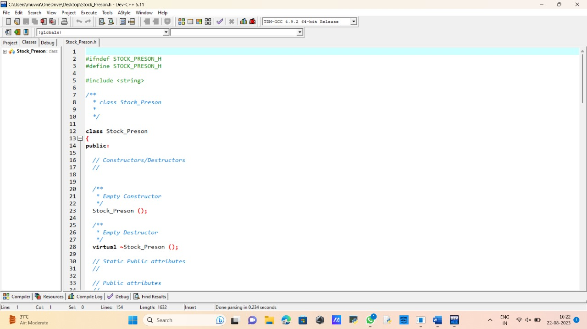

E-TICKETING

**USE CASE DIAGRAM**

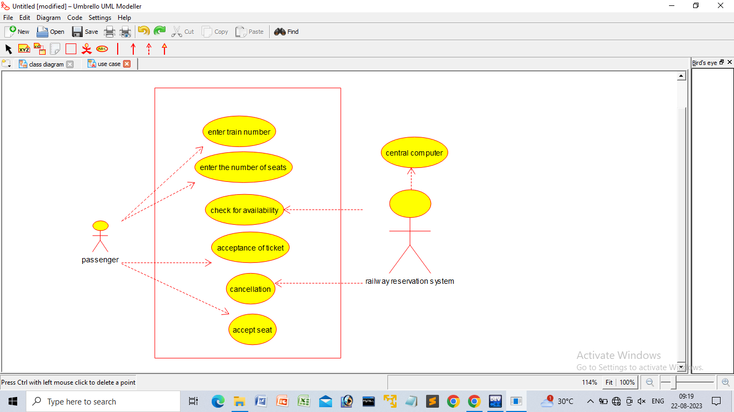

**CLASS DIAGRAM**

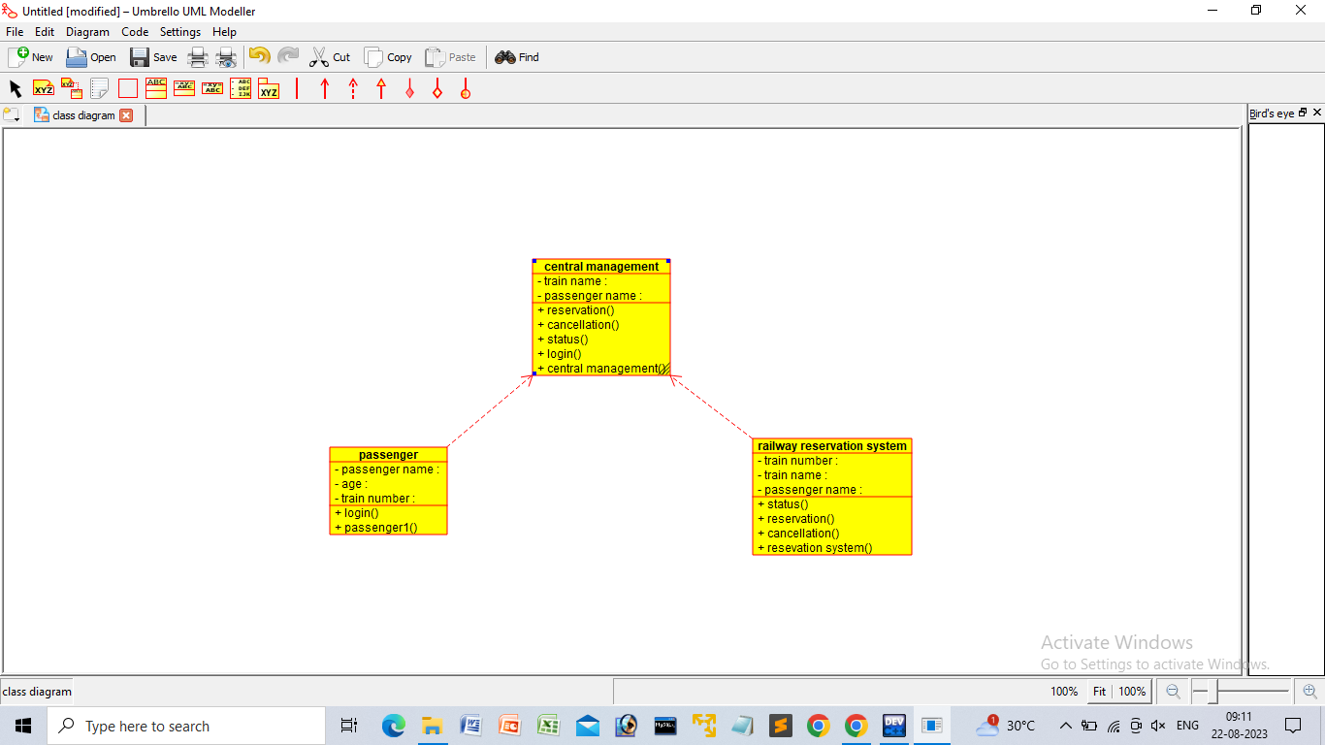

**ACTIVITY DIAGRAM**

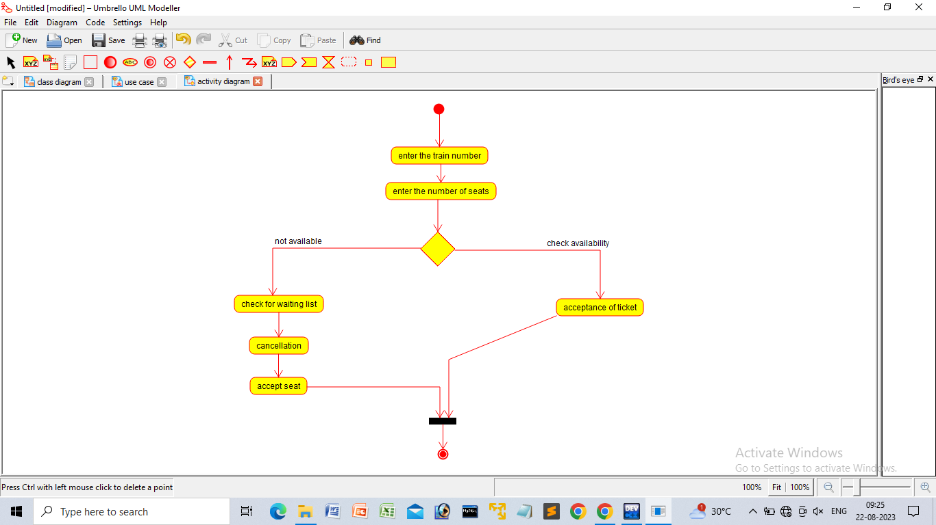

**STATE DIAGRAM**

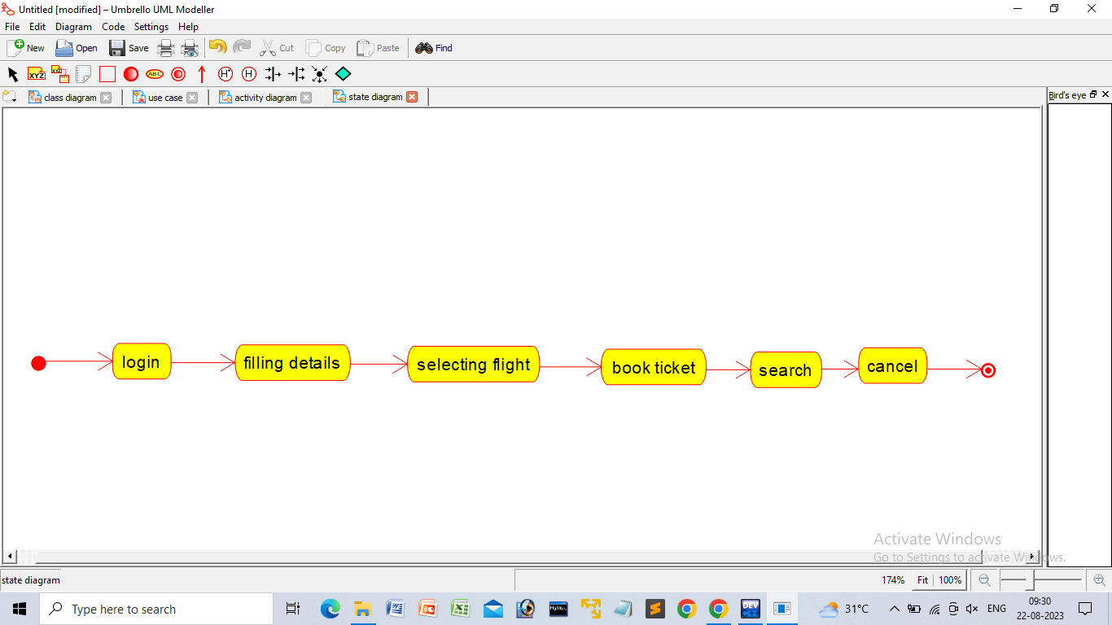

**SEQUENCE DIAGRAM**

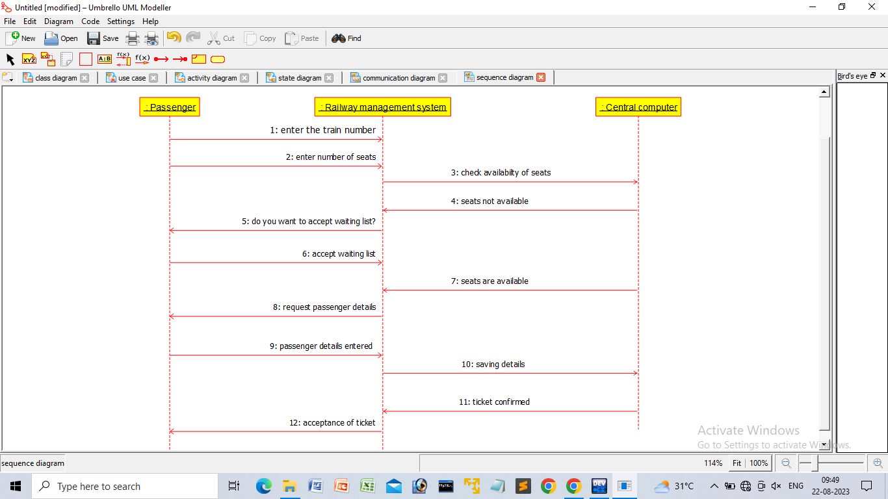

**COMPONENT DIAGRAM**

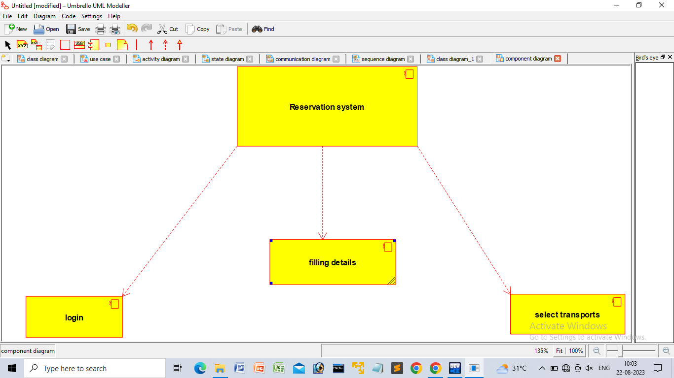

**COMMUNICATION DIAGRAM**

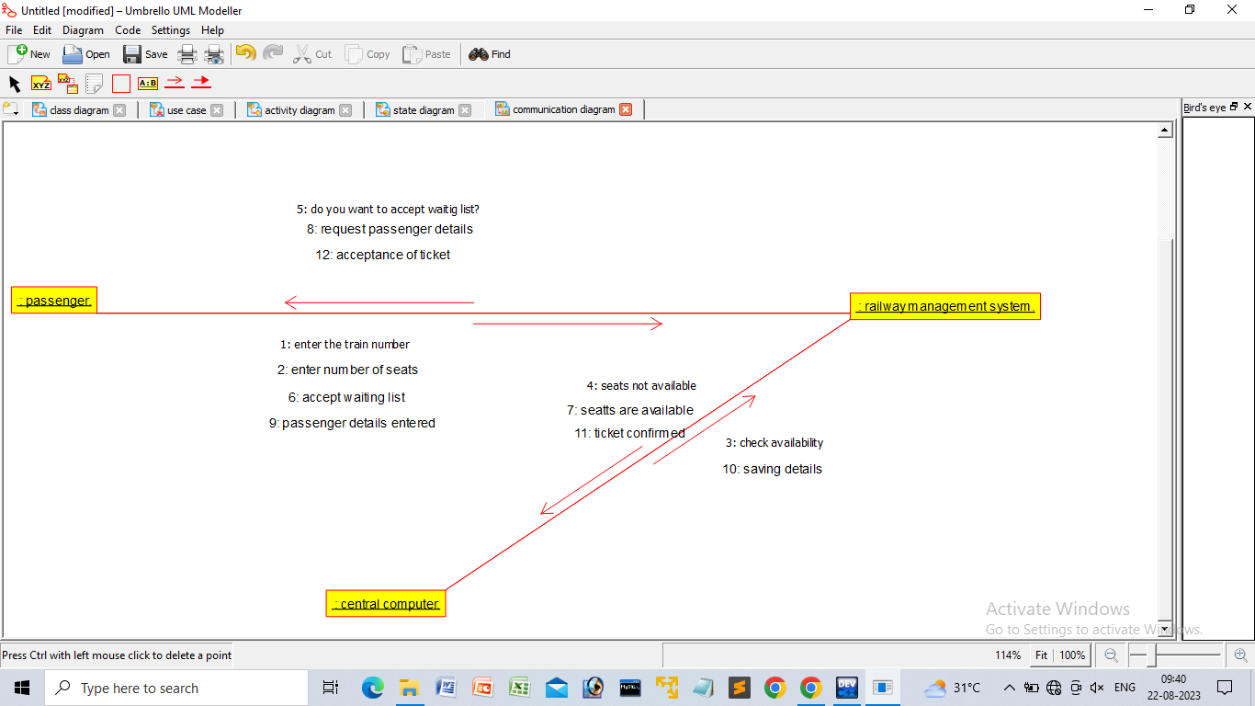

**PACKAGE DIAGRAM**

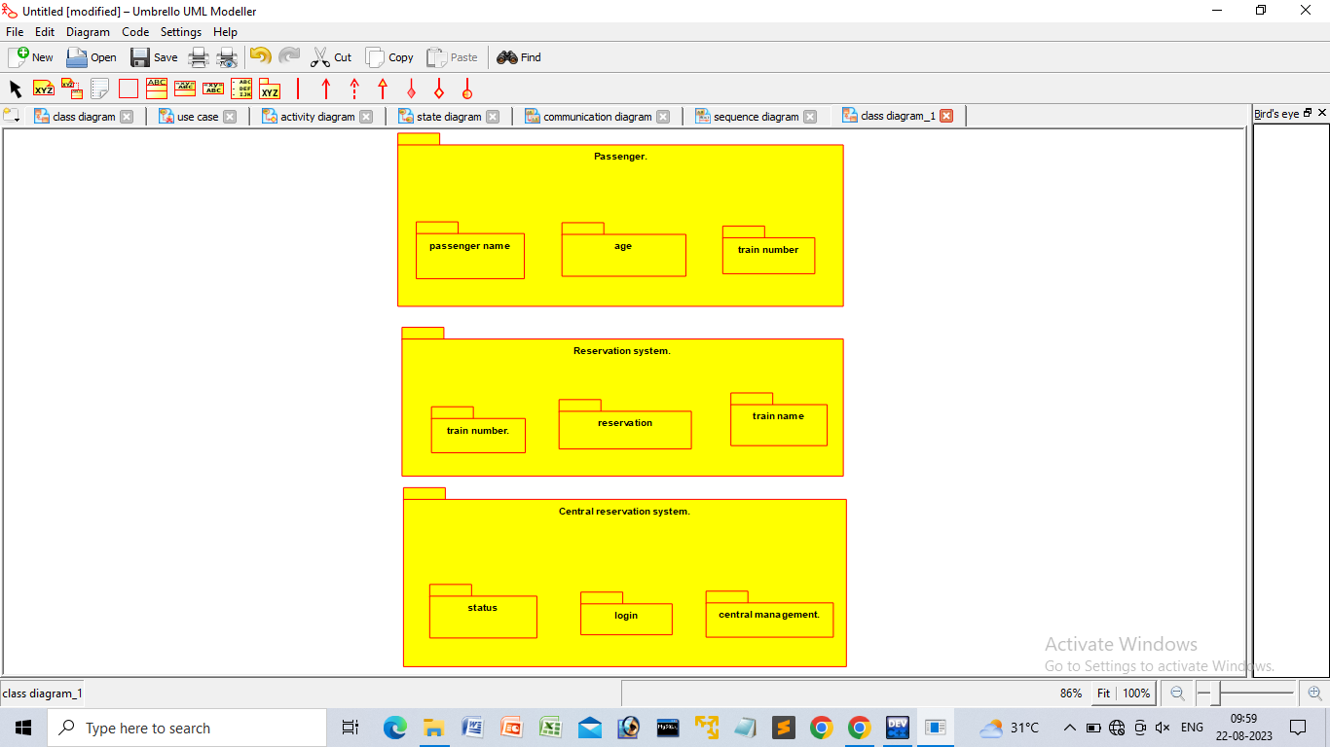

**DEPLOYMENT DIAGRAM**

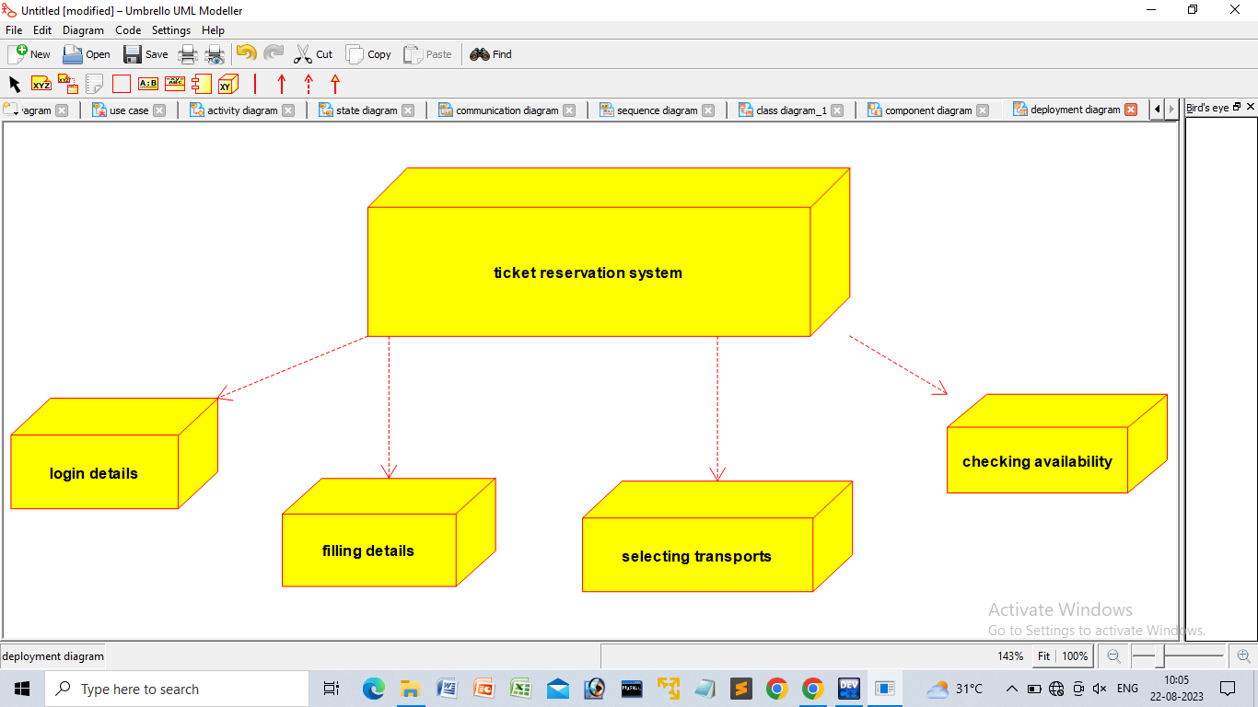

**PROGRAM**

